**Terraform Provisioning**

* Terraform has 3 basic provisioners
  + file: to copy the files from local to remote
  + local-exec: is used to execute commands in the machine where terraform is running
  + remote-exec: is used to executed commands on the machines created by terraform
* When we are working with remote system i.e. vm created by terraform we need to establish connection. Terraform has connection block which supports two kinds of connections
  + ssh
  + winrm

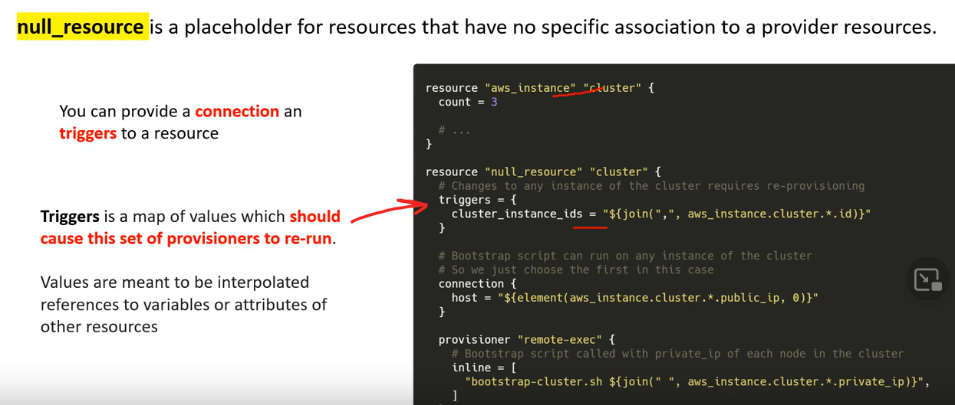

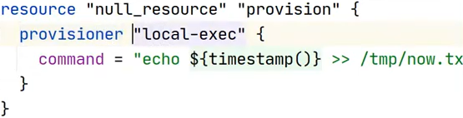

Above, We are taking timestamp when we are apply command are getting executed, we can run Ansible playbook, and so many things with null resource.